Frequently Asked Questions

What is a Mayoral Development Corporation?
A Mayoral Development Corporation (MDC) is a statutory body created to bring forward the regeneration of a defined area, bringing together stakeholders across public and private sectors to ensure its success. They have powers to acquire develop, hold, and dispose of land and property. They also have powers to facilitate the provision of infrastructure.
The MDC model has been used successfully in London and in Stockport and would be run by a Board that includes local democratically elected Members along with independent development experts to ensure a balance between accountability and technical expertise.

Why is a Mayoral Development Corporation proposed for the Old Trafford Regeneration area?
In Greater Manchester, we have developed a model that would allow us to harness the potential MDCs have to bring about large-scale regeneration while ensuring they fit with our unique local circumstances without creating unnecessary bureaucracy.
The internationally significant regeneration of the Old Trafford stadium offers a unique opportunity to utilise the MDC’s operating model to work with property owners, investors, and developers to realise the opportunity to deliver great places to live and work within its area. It will work to raise the profile of the development and secure benefits to local people and businesses.

The Old Trafford Regeneration MDC will include both Trafford Council and the Greater Manchester Combined Authority (GMCA), and it will be tasked with delivering this significant regeneration opportunity. It will be able to secure funding and acquire land, working alongside the Council, who will retain responsibility for planning decisions.

What are the development proposals for the Old Trafford Regeneration area?
The unique assets of the Old Trafford Regeneration area will be used to accelerate transformational regeneration that creates a world-class, sports-led visitor destination, a rich cultural and entertainment offer, delivers high quality homes, new businesses, creates thousands of new jobs and supports wider inclusive growth opportunities. The Old Trafford Regeneration MDC will establish the delivery framework to enable the Old Trafford area to become one of the best places in the UK to live, work, and visit and maximise its positive contribution locally and to the wider city region’s economy.
Establishing the Old Trafford Regeneration Mayoral Development Corporation will attract both public and private sector investment, paving the way for around 15,000 new homes, including affordable homes.
We’re proposing the MDC would work to secure benefits for local people and businesses. The MDC would want to work with the local community, property owners, investors and developers to help to deliver the ambitious plan and help to realise the benefits of developing the Old Trafford Regeneration area.

What area does the Old Trafford Regeneration MDC cover?

The proposed Old Trafford Regeneration MDC boundary is shown in the map below. It occupies a strategic location close to Manchester City Centre, Media City and the Manchester Ship Canal. The Old Trafford Regeneration area presents a remarkable opportunity to create one of Europe's most significant investment and regeneration initiatives. This transformative project promises to dramatically enhance economic performance and quality of life for the local area.
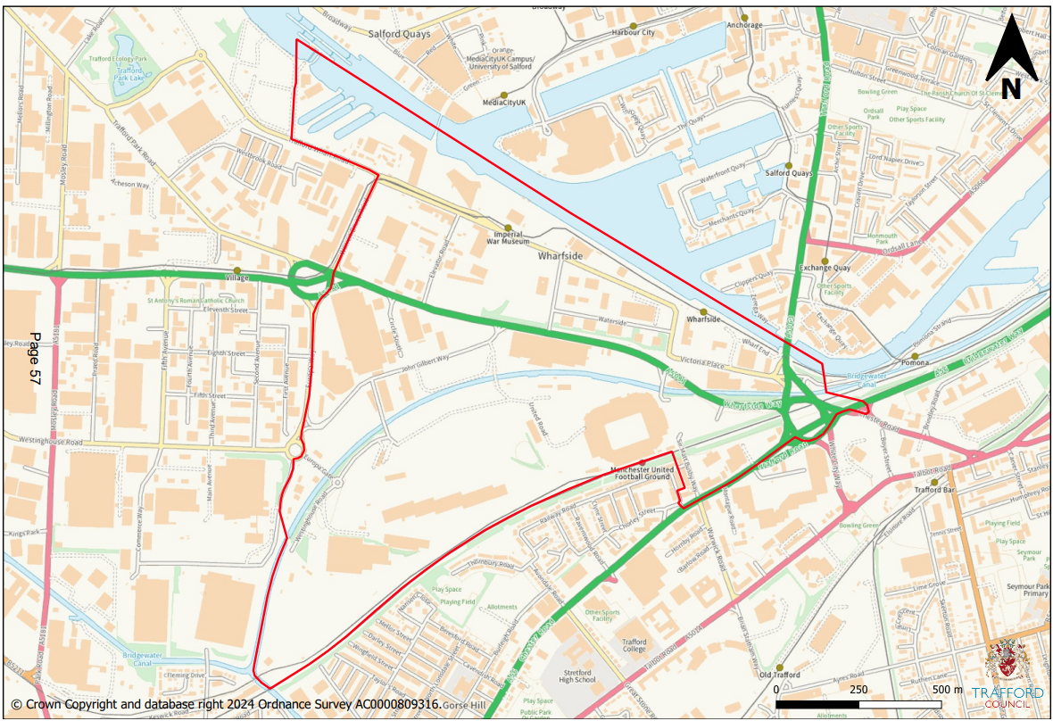

What is the proposed timeframe for the delivery of the Old Trafford Regeneration MDC?
The report on the responses to this consultation will be taken to Trafford Council’s Executive and the GMCA Meeting for approval in September. Assuming support for the proposal, the Mayor will then notify the relevant Government Minister (The Secretary of State for Housing, Communities and Local Government) who would establish the “The Old Trafford Regeneration Mayoral Development Corporation”. The corporation would likely be fully established by early 2026.

Will the MDC be exercising Compulsory Purchase Order powers?

While MDCs are able to acquire land using compulsory purchase powers, the Greater Manchester model seeks that acquisitions will be negotiated by agreement wherever possible. Experience from other Corporations is that such powers are employed sparingly and only when land is required for very specific purposes or public benefit.
We would urge anybody that is concerned about potential compulsory purchase or that is interested in selling their property within the MDC area to talk to a member of the team about their individual case.

What impact will the Old Trafford Regeneration MDC have on social and transport infrastructure?
The Old Trafford Regeneration area occupies a strategic location close to Liverpool Road, the M62 corridor and the Manchester Ship Canal. The MDC will focus on improving transport links, creating new homes, supporting local businesses and improving social infrastructure.
We’re proposing the MDC would work to secure benefits for local people and businesses to create a strong community with improvements to the provision of social infrastructure such as schools and access to GPs. The Old Trafford Regeneration area, within Trafford Wharfside, presents a remarkable opportunity to create one of Europe's most significant investment and regeneration initiatives. This transformative project promises to dramatically enhance economic performance and quality of life for the people living within the area, in the wider region and beyond.

How else can I share my views on the Old Trafford Regeneration MDC?
You can express your views by writing to the following address:
Old Trafford Regeneration Mayoral Development Corporation
Greater Manchester Combined Authority
Tootal Building
56 Oxford Street
Manchester
M1 6EU

If you would like any further information, to request the consultation materials in an alternative format or to access the materials using a translation service, please contact: engagement@greatermanchester-ca.gov.uk

What has the Stockport MDC achieved?
Set up in 2019, the MDC’s powers initially spanned the 130-acre brownfield masterplan dubbed Town Centre West.
In the five years since, Stockport MDC has made significant strides in transforming Town Centre West, with 1,200 new homes either complete or on site and £600 million in private investment secured during the first phase. Key achievements include the completion of the state-of-the-art Stockport Interchange with its two-acre park, 170,000 sq ft of Grade A office space at Stockport Exchange, and the transformation of the historic Weir Mill into a vibrant new neighbourhood, featuring apartments, green spaces, and areas for independent retail and leisure. A further 1,200 homes alongside retail, leisure, and office space will be delivered as the next phase of development at Stockport 8.

