Greater Manchester Hate Crime Plan

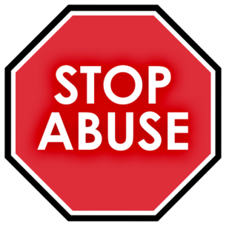
What do you think?
Easy Read
Please send completed surveys to engagement@greatermanchester-ca.gov.uk
by December 8, 2019

 | Introduction
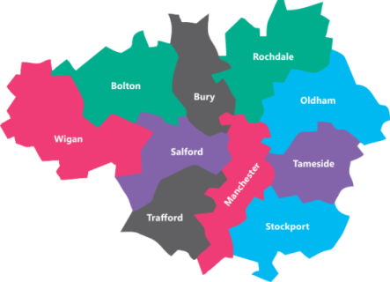 | Everyone should feel safe in Greater Manchester.
 | No-one should face violence, abuse or hate because of who they are, who they love, where they are from, what they look like or what they believe.
 | There are lots of great projects to stop hate crime in Greater Manchester.
 | We think if we work together then these can work better.
 | So we are writing the Greater Manchester Hate Crime Plan to help stop hate crime.
 | We want to hear from everyone in Greater Manchester whether you have experienced hate crime or not.
 | If you did not report it then we still want to hear about it.
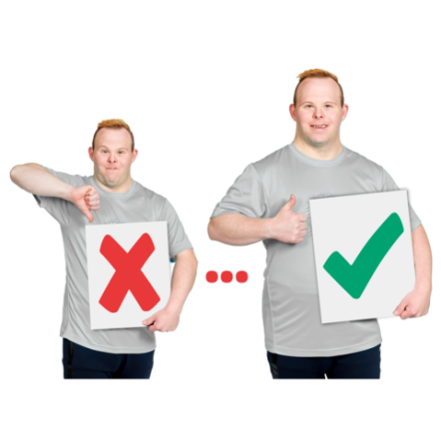 | Sharing your stories and ideas will help us understand better what is working and what can be improved.
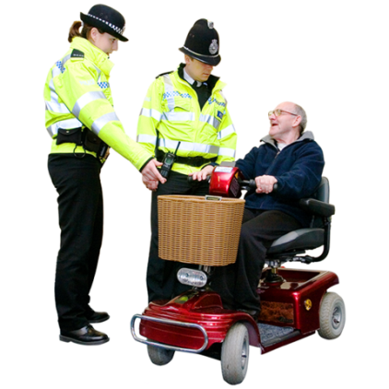 | Please do not use this survey to report a crime. If you wish to report a crime:  - in an emergency call 999  - in other situations call 101
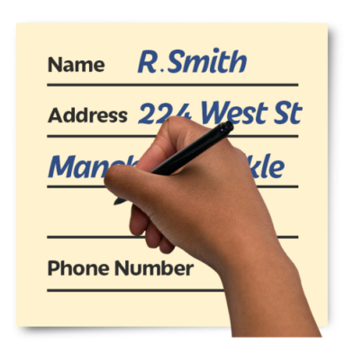 | Please do not write any names or personal information in this survey.
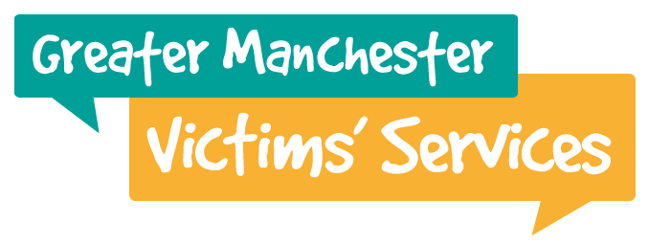 | If you have seen or been a victim you can find out how to report it at www.letsendhatecrime.com.
Hate incidents and hate crime

A hate incident is when someone is targeted because of:
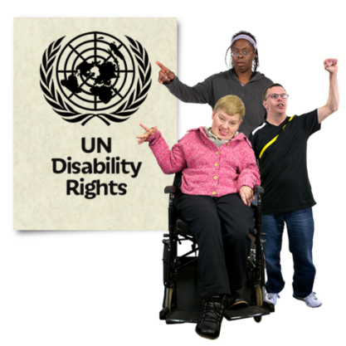 | - disability
 | - gender identity
 | - sexuality
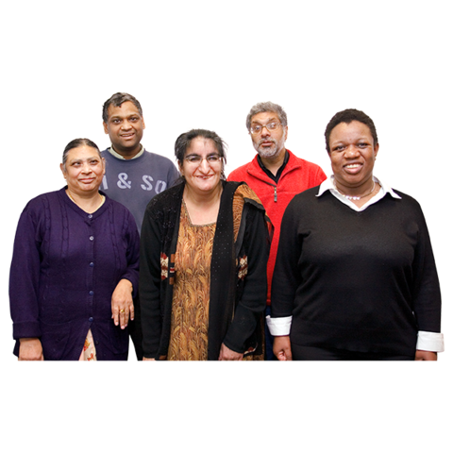 | - race
 | - religion
 | - culture - for example being a goth.
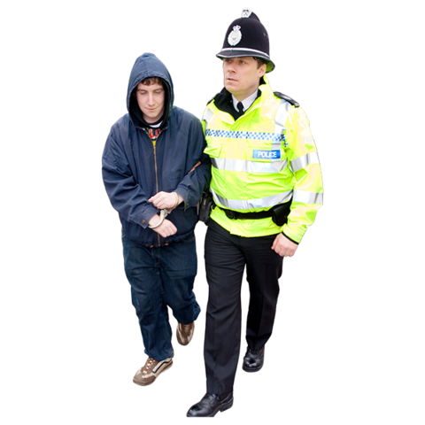 | A hate crime is when a hate incident breaks the law.
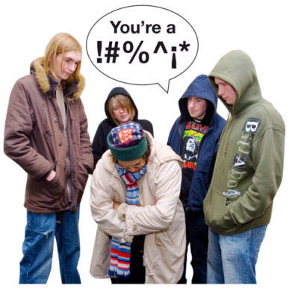 | It can involve saying bad things to someone, saying them on-line, physical attacks, criminal damage and many more crimes.
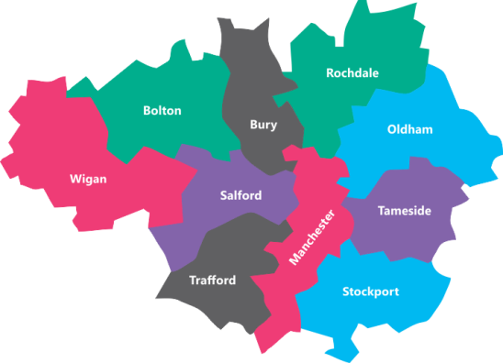 | In Greater Manchester we look at six types of hate incidents and hate crime. These are:
 | - Cultures or lifestyles
 | - Disability
 | - Gender identity
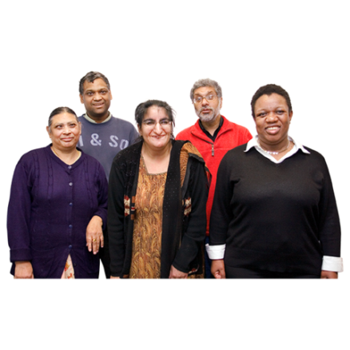 | - Race
 | - Religion or beliefs
 | - Sexuality
 | The Law Commission is currently looking at who is covered by hate crime law.
 | They may say hate against women and girls should be added.
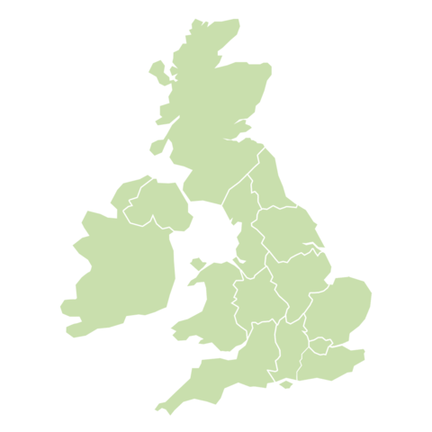 | Some other areas in the UK already treat hate against women and girls as a hate crime.
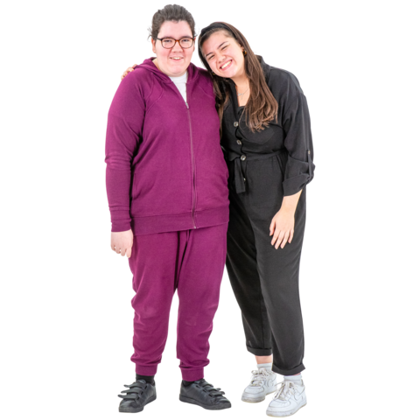 | 1. Do you think we should look at hate against women and girls in Greater Manchester?  - Yes  - No
 | Why do you think this?
 | 2. Do you think we should look at any other groups? If so please tell us who and why.
 | Our Priorities
 | A priority is an action that is more important than other actions.
 | We have worked with many people and organisations to choose the priorities in the plan.
 | We want to tell us what you think of them.
 | Priority 1: Raise awareness of hate incidents and hate crime
We will do this:
- Through a joined up campaign across Greater Manchester that raises awareness and encourages people to challenge hate
 | - By telling people about the Greater Manchester campaign for tackling hate crime - Let’s End Hate Crime and #WeStandTogether
3. Do you agree with this priority?
- Strongly agree
- Agree
- Disagree
- Strongly disagree
 | 4. Is there anything you would change?
 | Priority 2: Improve support for victims
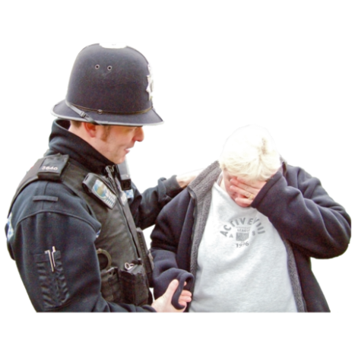 | We will do this by:  - Providing better support for victims
 | - Sending them to the right support services
- Promoting the Let’s End Hate Crime website as a place to go to get:
  - counselling and emotional support
  - advocacy
  - help with reporting hate crime
 | - Training staff who work with the public about the support services they can send people to.
 | Third Party Reporting Centres are organisations where people can go to report incidents and receive support.
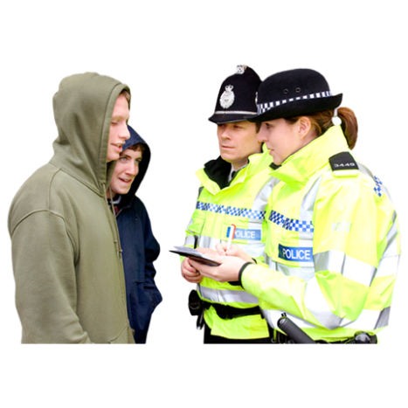 | Some people find it hard to report a hate incident or hate crime to the police. These centres are not run by the police.
 | Staff at reporting centres will support people to report an incident or report it on their behalf.
5. Do you agree with this priority?
- Strongly agree
- Agree
- Disagree
- Strongly disagree
 | 6. Is there anything you would change?
 | Priority 3: Increase reporting of hate incidents and hate crime
We will do this by:
- Supporting Third Party Reporting Centres
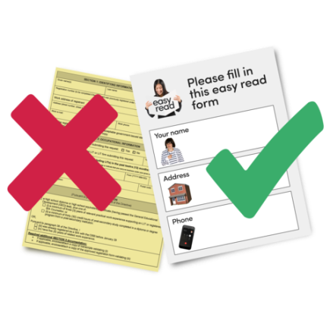 | - Providing tools to help people report hate crimes and incidents
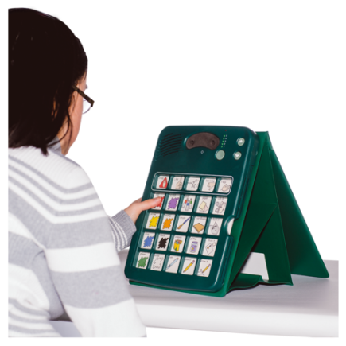 | - Providing different ways for people report hate crimes and incidents
 | - Raising awareness of what are hate incidents and crimes and how to report them
7. Do you agree with this priority?
- Strongly agree
- Agree
- Disagree
- Strongly disagree
 | 8. Is there anything you would change?
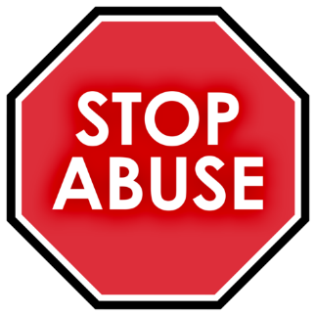 | Priority 4: Stop hate incidents and hate crimes
We will do this by:
- Teaching people about the effects of hate crime
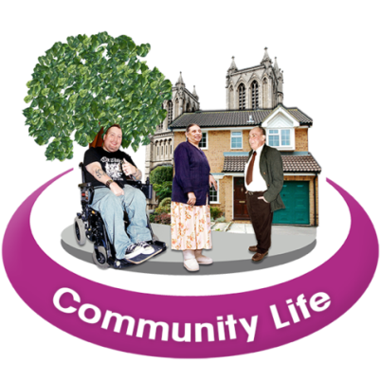 | - Supporting inclusion
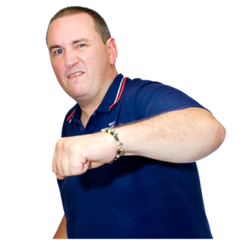 | - Supporting communities to challenge extreme political or religious views
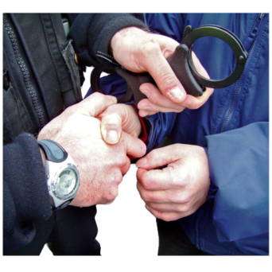 | - Taking action against people that commit hate crime
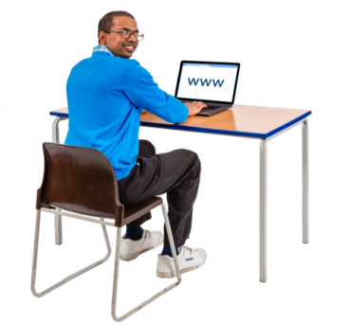 | - Taking action against online hate crime
9. Do you agree with this priority?
- Strongly agree
- Agree
- Disagree
- Strongly disagree
 | 10. Is there anything you would change?
 | Greater Manchester Hate Crime Awareness Week
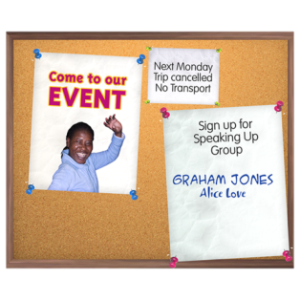 | Every February Hate Crime Awareness Week aims to:  - Raise awareness of hate crime and incidents
 | - Increase reporting of hate crime and incidents
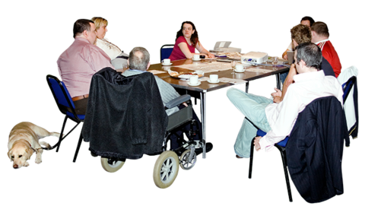 | - Talk to community groups and faith groups
11. Have you heard of Hate Crime Awareness Week?
- Yes
- No
 | If yes, how did you hear about it?
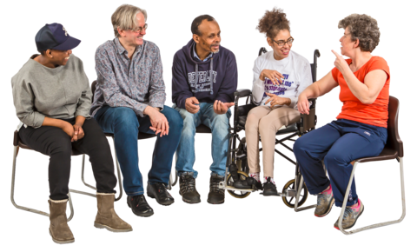 | 12. Have you attended any Hate Crime Awareness Week events?  - Yes  - No
 | If yes, which events did you attended?
.

 | 13. Previous weeks have focused on not being a bystander and hate crime on public transport. What should future Hate Crime Awareness Weeks focus on?
14. In Greater Manchester in the last 5 years have you seen or been a victim of a hate crime or hate incident?
- Yes I’ve been a victim of hate crime
- Yes I’ve seen hate crime
- No – go to Page 34
15. Where did you report the most recent hate crime you experienced?
  - I didn't report it – go to Page 31
  - Police
  - Housing office
  - Council/ Local authority
  - True Vision website
  - Third Party Reporting Centre
  - Other - where did you report it?
,,,,,,,,,,,,,,,,,,,,,,,,,,,,,,,,,,,,,,,,
,,,,,,,,,,,,,,,,,,,,,,,,,,,,,,,,,,,,,,,,
16. Were you satisfied with the response from Greater Manchester Police?
- Very satisfied
- Fairly satisfied
- Fairly unsatisfied
- Very unsatisfied

Why do you think this?
17. Were you satisfied with the communication from Greater Manchester Police?
- Very satisfied
- Fairly satisfied
- Fairly unsatisfied
- Very unsatisfied

Why do you think this?
18. After reporting it, did you feel you needed any support?
  - Yes
  - No
  - Can't remember
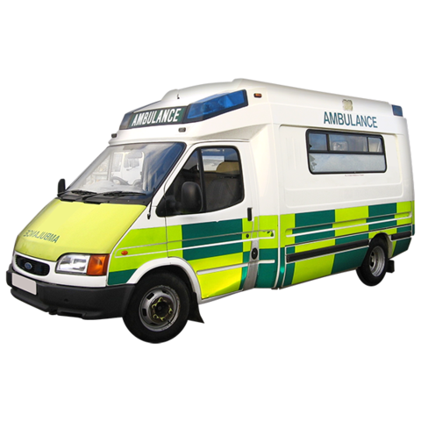 | 19. Were you offered? (please tick all that apply)  - Ambulance / first aid  - Repairs - things like smashed windows and changing locks  - Victim Support  - Other emotional support like counselling  - I was not offered any support  - Cannot remember  - Other support - please say:  ,,,,,,,,,,,,,,,,,,,,,,,,,,,,,,,,,,,,,,,,  ,,,,,,,,,,,,,,,,,,,,,,,,,,,,,,,,,,,,,,,,
20. If you were supported by any of these services, how satisfied were you with the support?
- Ambulance / first aid
  - Very satisfied
  - Fairly satisfied
  - Fairly unsatisfied
  - Very unsatisfied
- Repairs
  - Very satisfied
  - Fairly satisfied
  - Fairly unsatisfied
  - Very unsatisfied
- Victim Support
  - Very satisfied
  - Fairly satisfied
  - Fairly unsatisfied
  - Very unsatisfied
- Other emotional support like counselling
  - Very satisfied
  - Fairly satisfied
  - Fairly unsatisfied
  - Very unsatisfied
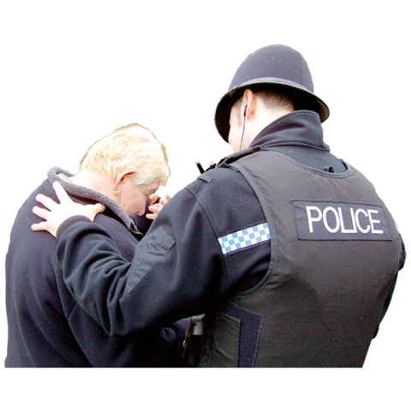 | - Other support  - Very satisfied  - Fairly satisfied  - Fairly unsatisfied  - Very unsatisfied
 | Why do you think this?
 | 21. What could be done to improve the support received?
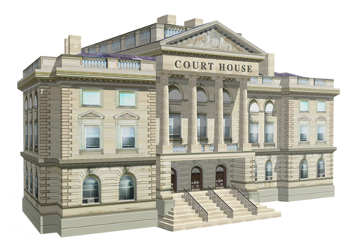 | 22. Did the case go to court?  - Yes  - No – go to Page 34  - Don't know – go to Page 34
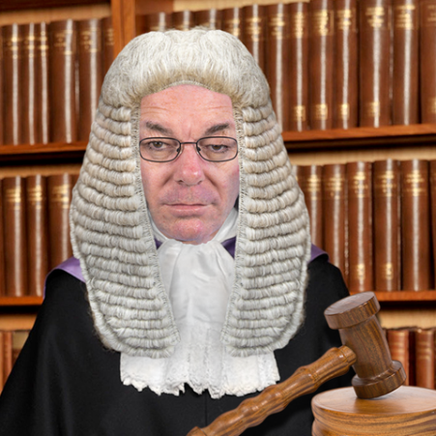 | 23. Did you have to go to court?  - Yes, Magistrate's Court  - Yes, Crown Court  - Yes, but not sure which court  - No – go to Page 34
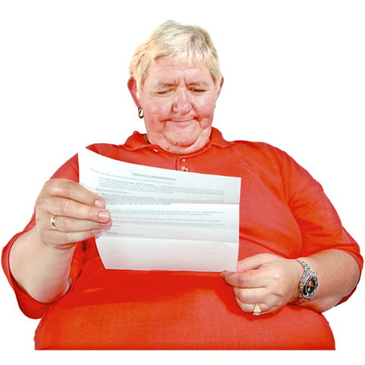 | 24. Were you satisfied with the communication before the trial?  - Very satisfied  - Fairly satisfied  - Fairly unsatisfied  - Very unsatisfied
 | Why do you think this?
 | 25. What could have improved the communication you received about the trial?
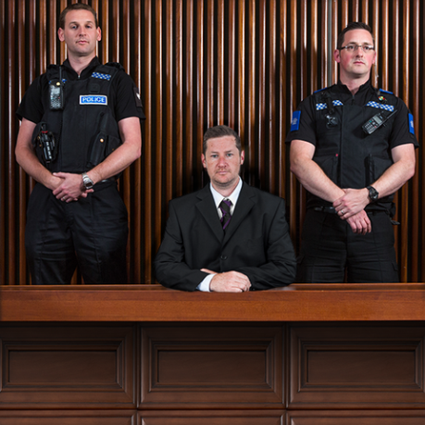 | 26. Were you offered the chance to look around the court before the trial?  - Yes  - No – go to Page 28
27. Did you visit the court before the trial?
- Yes
- No – please say why?
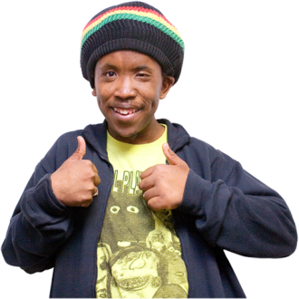 | 28. If you visited court before the trial, were you satisfied with the visit?  - Very satisfied  - Fairly satisfied  - Fairly unsatisfied  - Very unsatisfied  Why?
 | 29. What could have improved your visit?
30. How satisfied were you with your experience at court?
- Very satisfied
- Fairly satisfied
- Fairly unsatisfied
- Very unsatisfied
Why?
 | 31. What could have improved your experience?
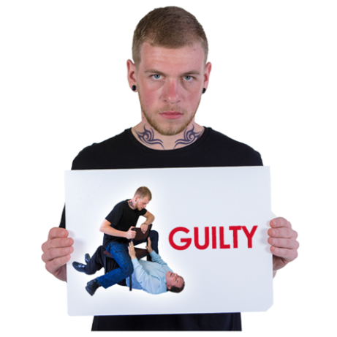 | 32. Was the person found guilty or not guilty?  - Guilty  - Not guilty  - Don't know
33. If they were found guilty, were you satisfied with the sentence?
- Very satisfied
- Fairly satisfied
- Fairly unsatisfied
- Very unsatisfied
Why do you think that?
34. How long did it take from reporting the crime to the end of the court hearing?
- Less than 1 month
- 1-2 months
- 3-6 months
- 7-12 months
- 13-18 months
- 19-24 months (2 years)
- More than 2 years
- Don’t know
35. Were you satisfied with how long it took?
- Very satisfied
- Fairly satisfied
- Fairly unsatisfied
- Very unsatisfied
 | Why do you think this?
36. Were you offered any support services after court? (please tick all that apply)
- Victim Support
- Other emotional support like counselling
- I was not offered any support
  - Other support - please say:
,,,,,,,,,,,,,,,,,,,,,,,,,,,,,,,,,,,,,,,,
37. If you were supported by any of these services, how satisfied were you with the support?
- Victim Support
  - Very satisfied
  - Fairly satisfied
  - Fairly unsatisfied
  - Very unsatisfied
- Other emotional support like counselling
  - Very satisfied
  - Fairly satisfied
  - Fairly unsatisfied
  - Very unsatisfied
- Other support
  - Very satisfied
  - Fairly satisfied
  - Fairly unsatisfied
  - Very unsatisfied
 | Why do you think this?
38. What could be done to improve the support you got?

Go to Page 34 – Other support

If you didn’t report this crime…

39. Why did you not report it?
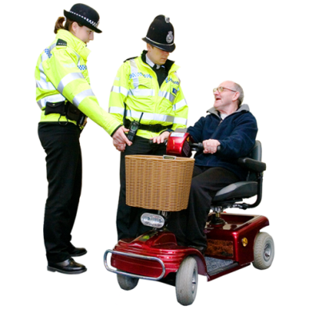 | 40. Did you need any support after this crime?  - Yes  - No  - Can’t remember
41. Did you use any of these support services? (please tick all that apply)
- Victim Support
- Other emotional support like counselling
- I was not offered any support
  - Other support - please say:
,,,,,,,,,,,,,,,,,,,,,,,,,,,,,,,,,,,,,,,,
,,,,,,,,,,,,,,,,,,,,,,,,,,,,,,,,,,,,,,,,
42. If you were supported by any of these services, how satisfied were you with the support?
- Victim Support
  - Very satisfied
  - Fairly satisfied
  - Fairly unsatisfied
  - Very unsatisfied
- Other emotional support like counselling
  - Very satisfied
  - Fairly satisfied
  - Fairly unsatisfied
  - Very unsatisfied
- Other support
  - Very satisfied
  - Fairly satisfied
  - Fairly unsatisfied
  - Very unsatisfied
 | Why do you think this?
 | 43. What could be done to improve the support you got?

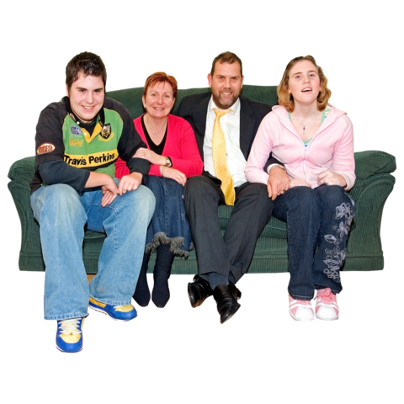 | Other support  44. Did support from your friends and family help you to cope and recover?  - A great deal  - Quite a bit  - Somewhat  - Very little  - Not at all  - I didn’t ask anyone for support
 | 45. Is there anything else you feel would have helped you to cope and recover?
 | 46. Is there anything else you want to say?
 | 47. What else can be done to stop hate crime in Greater Manchester?
 | 48. How can the public help to stop hate crime?
About You
We need to hear from lots of different types of people.

So these questions are about you.
They help us make sure we hear from a range of voices.

If there are questions you do not want to answer please choose the ‘Do not want to say’ option.
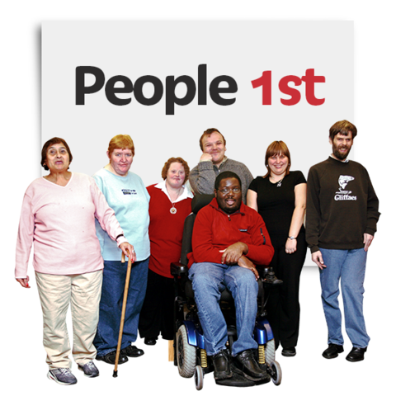 | Are you responding on behalf of an organisation?  - Yes  - No  - Do not want to say
Have you ever been a victim of crime?
- Yes
- No
- Do not want to say
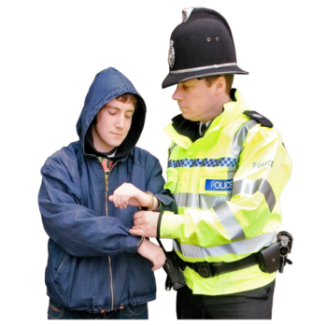 | Have you ever broken the law?  - Yes  - No  - Do not want to say
Which local authority area do you live in or work in?
- Bolton
- Bury
- Manchester
- Oldham
- Rochdale
- Salford
- Stockport
- Tameside
- Trafford
- Wigan
- A Greater Manchester organisation
- A North West organisation
- A national organisation
- Do not want to say
What is your ethnic group?
- Asian or Asian British – Indian
- Asian or Asian British – Pakistani
- Asian or Asian British – Bangladeshi
- Asian or Asian British – Chinese
- Asian or Asian British - Any other Asian background
- Black or Black British – Caribbean
- Black or Black British – African
- Black or Black British - Any other Black background
- Mixed - White and Black Caribbean
- Mixed - White and Black African
- Mixed - White and Asian
- Mixed - Any other mixed background
- White – English/Welsh/Scottish/Northern Irish/British
- White – Irish
- White - Gypsy or Irish Traveller
- White - Eastern European
- White - Any other White Background
- Other ethnic group – Arab
- Other ethnic group – Other
- Do not want to say
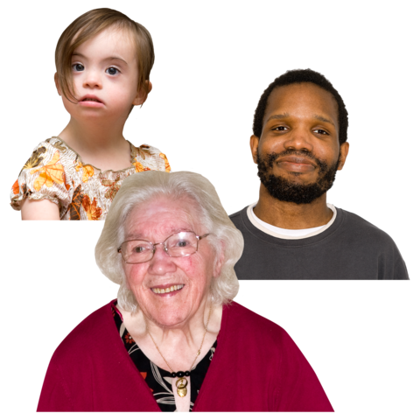 | How old are you?  - Under 18  - 18-24  - 25-34  - 35-44  - 45-54  - 55-64  - 65-74  - 75+  - Do not want to say
What is your religion?
- Buddhist
- Christian
- Hindu
- Jewish
- Muslim
- Sikh
- Other religion
- No religion
- Do not want to say
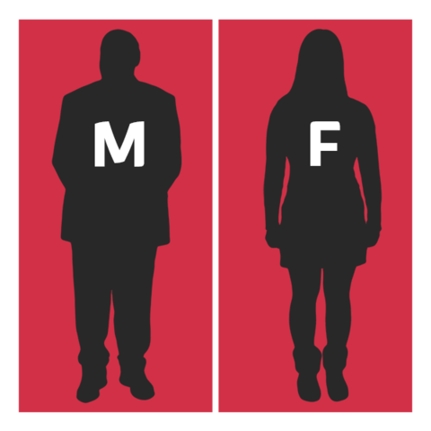 | How do you talk about your gender?  - A man  - A woman  - Non-binary  - In another way  - Do not want to say
Are you trans or transgender?
- Yes
- No
- Do not want to say
Are you?
- Bisexual
- Gay or lesbian
- Heterosexual or straight
- Other, please say:
- Do not want to say
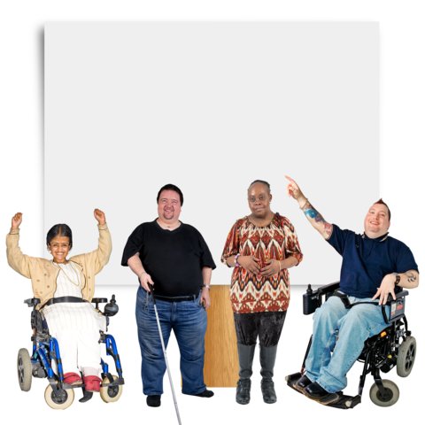 | Are you disabled?  - No  - Yes - learning disability  - Yes - mental ill health  - Yes - mobility impairment  - Yes - sensory impairment  - Yes – other, please say:  - Do not want to say
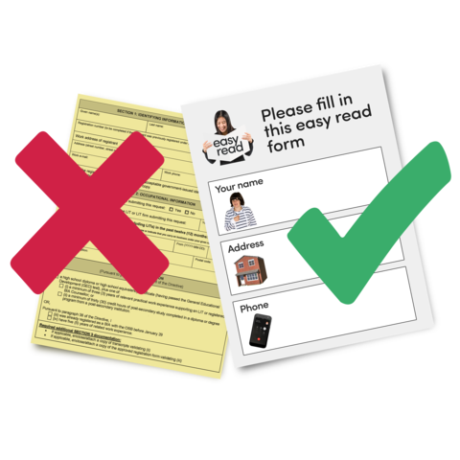 | I found it easy to navigate my way through the survey  - Strongly agree  - Agree  - Disagree  - Strongly disagree
The survey has given me the opportunity to have my say
- Strongly agree
- Agree
- Disagree
- Strongly disagree
I feel better informed as a result of taking part in this survey
- Strongly agree
- Agree
- Disagree
- Strongly disagree
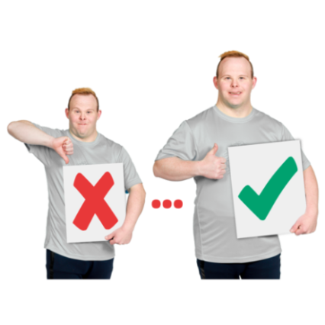 | I feel clear about what I have been able to change through this survey  - Strongly agree  - Agree  - Disagree  - Strongly disagree
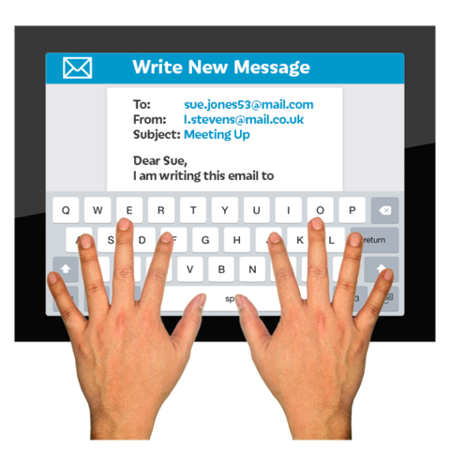 | How did you hear about this survey?  - Email from Greater Manchester Combined Authority  - Email from someone else  - Twitter – Mayor of Greater Manchester (Andy Burnham)  - Twitter – Deputy mayor of Greater Manchester (Bev Hughes)  - Twitter – Greater Manchester Combined Authority  - Twitter – Other  - Facebook – Mayor of Greater Manchester  - Facebook–Greater Manchester Combined Authority  - Cannot remember  - Other – please say?  ,,,,,,,,,,,,,,,,,,,,,,,,,,,,,,,,,,,,,,,,  ,,,,,,,,,,,,,,,,,,,,,,,,,,,,,,,,,,,,,,,,
Is it OK if we publish what you say on gmconsult.org?
- Yes - publish in full
- Yes - publish but do not put my name on it
- No

